PeopleHub Manual 23 October 2025

Introduction:

As part of the quality assurance process, a manual audit has been initiated to validate the results generated by the automated vulnerability scanning tools. Each finding is being reviewed to determine its accuracy and relevance, with the objective of classifying them as either true positives (valid security issues) or false positives (non-exploitable or misidentified issues).
This step ensures the reliability of the final report by eliminating noise from automated tools and confirming the presence and impact of vulnerabilities through manual testing techniques. The scan is done twice a month

Table of Contents
Introduction: 2
25Q3 PeopleHub Manual Audit 4
Executive Summary 4
Strict transport Security Not Enforced 4
Cross Origin Resource Sharing 5
Input Returned in Response 7
TLS Certificate 10

PeopleHub Manual 23 October 2025

Executive Summary
The chart below shows the aggregated numbers of issues identified in each category. Solid colored bars represent issues with a confidence level, and the bars fade as the confidence level falls.
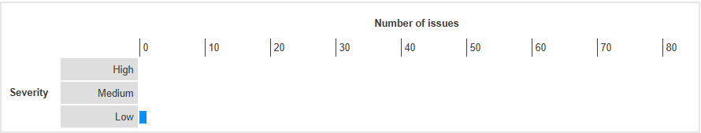

Strict transport Security Not Enforced
Severity | Low
Finding Type | False positive

Description
The application fails to prevent users from connecting to it over unencrypted connections. An attacker able to modify a legitimate user's network traffic could bypass the application's use of SSL/TLS encryption, and use the application as a platform for attacks against its users. This attack is performed by rewriting HTTPS links as HTTP, so that if a targeted user follows a link to the site from an HTTP page, their browser never attempts to use an encrypted connection. The sslstrip tool automates this process.
To exploit this vulnerability, an attacker must be suitably positioned to intercept and modify the victim's network traffic.This scenario typically occurs when a client communicates with the server over an insecure connection such as public Wi-Fi, or a corporate or home network that is shared with a compromised computer. Common defenses such as switched networks are not sufficient to prevent this. An attacker situated in the user's ISP or the application's hosting infrastructure could also perform this attack. Note that an advanced adversary could potentially target any connection made over the Internet's core infrastructure.
Link Tested
/.well-known/openid-configuration

Steps
- Access the path reported with HSTS not enabled
- Verify whether the HSTS header is set or not
- The HSTS header is present
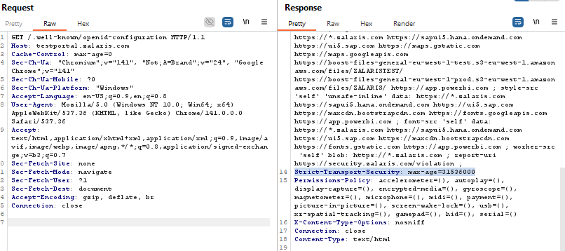
WORKLOG

When | What | Who | Recommended Action
04 November 2025 | 25Q3 PeopleHub Auto 23 October - Strict Transport Security Header Not Enforced re-test | CSOC | False positive . No Action Needed

Cross Origin Resource Sharing

Severity | Informational
Finding Type | False Positive

An HTML5 cross-origin resource sharing (CORS) policy controls whether and how content running on other domains can perform two-way interaction with the domain that publishes the policy. The policy is fine-grained and can apply access controls per-request based on the URL and other features of the request.
If another domain is allowed by the policy, then that domain can potentially attack users of the application. If a user is logged in to the application, and visits a domain allowed by the policy, then any malicious content running on that domain can potentially retrieve content from the application, and sometimes carry out actions within the security context of the logged in user.
Even if an allowed domain is not overtly malicious in itself, security vulnerabilities within that domain could potentially be leveraged by an attacker to exploit the trust relationship and attack the application that allows access. CORS policies on pages containing sensitive information should be reviewed to determine whether it is appropriate for the application to trust both the intentions and security posture of any domains granted access.
Links reported
- /neptune/efile_neptune_app_ess
- /neptune/zalaris_launchpad_standard
- /neptune/zmfp_carbon_footprint
- /neptune/zmfp_dash_ess_carbon_fp
- /neptune/zmfp_dash_ess_efile
- /neptune/zmfp_dash_ess_lvreq_overview
- /neptune/zmfp_dash_ess_paid_vacation
- /neptune/zmfp_dash_ess_sickness
- /neptune/zmfp_dash_ess_time_reg
- /neptune/zmfp_ess_payslip
- /neptune/zmfp_leave_request
- /neptune/zmfp_my_receipts
- /neptune/zmfp_objects_on_loan_emp
- /neptune/zmfp_personal_profile
- /neptune/zmfp_photo_upload_new
- /neptune/zmfp_portal_notes
- /neptune/zmfp_startpage_calendar
- /neptune/zmfp_team_status
- /neptune/zmfp_time_entry_v2
- /neptune/zmfp_time_statement
- /neptune/zmfp_travel_create_expense_rep
- /neptune/zmfp_travel_details
- /neptune/zmfp_travel_overview

Steps
- Login to PeopleHub
- Analyze whether the Access-Control-Allow-Origin Header has been set or not
- The Access Control Allow Origin Header is set t o *
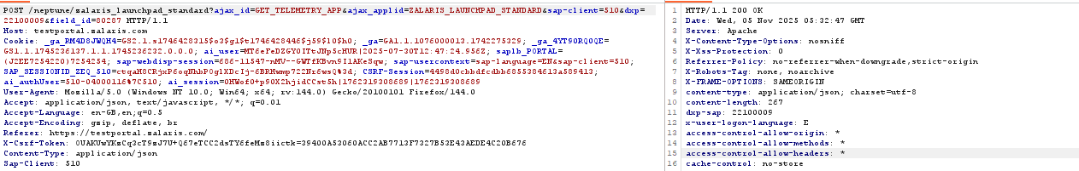
- Access Control Allow Credentials has not been set. This prevents the access to resources with the user credentials from third party domains
- Browsers will not send Cookies or HTTP authentication with Cross Origin requests . This prevents Cross Origin Resource Sharing for a authenticated request arising from third party or attacker domain

WORKLOG
When | What | Who | Recommended Action
4 November 2025 | 25Q3 PeopleHub Auto 23 October- Cross Origin Resource Sharing re-test | CSOC | False Positive. No Action Needed

Input Returned in Response

Severity | Informational
Finding Type

Description

Reflection of input arises when data is copied from a request and echoed into the application's immediate response.
Input being returned in application responses is not a vulnerability in its own right. However, it is a prerequisite for many client-side vulnerabilities, including cross-site scripting, open redirection, content spoofing, and response header injection. Additionally, some server-side vulnerabilities such as SQL injection are often easier to identify and exploit when input is returned in responses. In applications where input retrieval is rare and the environment is resistant to automated testing (for example, due to a web application firewall), it might be worth subjecting instances of it to focused manual testing.
Links Reported
- /neptune/zmfp_portal_notes [name of an arbitrarily supplied URL parameter]
- /neptune/zmfp_startpage_calendar [name of an arbitrarily supplied URL parameter]
- /neptune/zmfp_team_status [ajax_applid parameter]
- /neptune/zmfp_team_status [ajax_id parameter]
- /neptune/zmfp_team_status [dxp parameter]
- /neptune/zmfp_team_status [field_id parameter]
- /neptune/zmfp_team_status [name of an arbitrarily supplied URL parameter]
- /neptune/zmfp_team_status [sap-client parameter]
- /neptune/zmfp_time_entry_v2 [ajax_applid parameter]
- /neptune/zmfp_time_entry_v2 [ajax_id parameter]
- /neptune/zmfp_time_entry_v2 [dxp parameter]
- /neptune/zmfp_time_entry_v2 [field_id parameter]
- /neptune/zmfp_time_entry_v2 [name of an arbitrarily supplied URL parameter]
- /neptune/zmfp_time_entry_v2 [sap-client parameter]
- /neptune/zmfp_time_statement [ajax_applid parameter]
- /neptune/zmfp_time_statement [ajax_id parameter]
- /neptune/zmfp_time_statement [dxp parameter]
- /neptune/zmfp_time_statement [field_id parameter]
- /neptune/zmfp_time_statement [name of an arbitrarily supplied URL parameter]
- /neptune/zmfp_time_statement [sap-client parameter]
- /neptune/zmfp_travel_create_expense_rep [ajax_applid parameter]
- /neptune/zmfp_travel_create_expense_rep [ajax_id parameter]
- /neptune/zmfp_travel_create_expense_rep [ajax_value parameter]
- /neptune/zmfp_travel_create_expense_rep [dxp parameter]
- /neptune/zmfp_travel_create_expense_rep [field_id parameter]
- /neptune/zmfp_travel_create_expense_rep [name of an arbitrarily supplied URL parameter]
- /neptune/zmfp_travel_create_expense_rep [sap-client parameter]
- /neptune/zmfp_travel_details [ajax_applid parameter]
- /neptune/zmfp_travel_details [ajax_id parameter]
- /neptune/zmfp_travel_details [ajax_value parameter]
- /neptune/zmfp_travel_details [dxp parameter]
- /neptune/zmfp_travel_details [field_id parameter]
- /neptune/zmfp_travel_details [name of an arbitrarily supplied URL parameter]
- /neptune/zmfp_travel_details [sap-client parameter]
- /neptune/zmfp_travel_overview [ajax_applid parameter]
- /neptune/zmfp_travel_overview [ajax_id parameter]
- /neptune/zmfp_travel_overview [ajax_value parameter]
- /neptune/zmfp_travel_overview [dxp parameter]
- /neptune/zmfp_travel_overview [field_id parameter]
- /neptune/zmfp_travel_overview [name of an arbitrarily supplied URL parameter]
- /neptune/zmfp_travel_overview [sap-client parameter]
- /neptune/zmfp_universal_inbox [name of an arbitrarily supplied URL parameter]
- /oauth/TokensViewHandler [URL path filename]
- /oauth/TokensViewHandler [name of an arbitrarily supplied URL parameter]
- /oauth/authorize [URL path filename]
- /oauth/authorize [name of an arbitrarily supplied URL parameter]
- /oauth/generate_authz_code [URL path filename]
- /oauth/generate_authz_code [name of an arbitrarily supplied URL parameter]
- /oauth/token [name of an arbitrarily supplied URL parameter]
- /oauth2/v2.0/ [name of an arbitrarily supplied URL parameter]
- /sap/bc/contentserver/510 [URL path filename]
- /sap/bc/contentserver/510 [name of an arbitrarily supplied URL parameter]
- /sap/bc/gui/sap/its/webgui [URL path filename]
- /sap/bc/gui/sap/its/webgui [name of an arbitrarily supplied URL parameter]
- /sap/bc/gui/sap/its/webgui [~transaction parameter]

Steps
- Login to PeopleHub Capture the request using Burp-suite
- The request and response form the automated audit when analyzed gives the following conclusion
- All the request with the reflected input returned in the response are redirected to Login Page
- The reflected inputs are attached to the Location Header

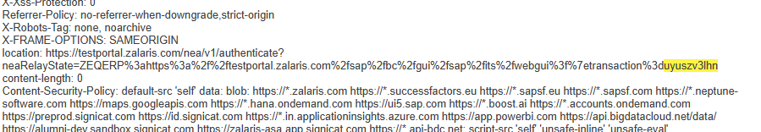

- Access the URL with response reflected, application re-directs the user to 404 Not Found Page

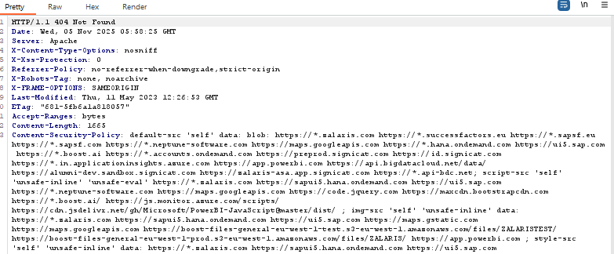
- Injection of XSS scripts also received 404 Not Found Error

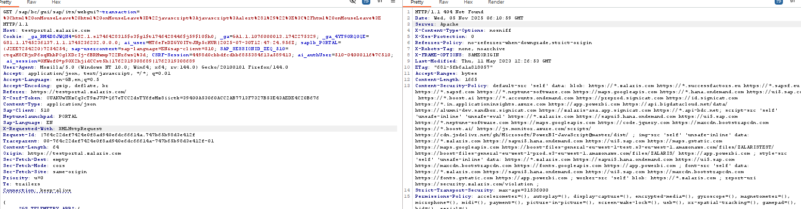

WORKLOG
When | What | Who | Recommended Action
04 November 2025 | 25Q3 PeopleHub Auto 23 October - Input Returned in Response re-test | CSOC | False positive . No Action Needed

TLS Certificate

Severity | Informational
Finding Type | NA

Description
TLS (or SSL) helps to protect the confidentiality and integrity of information in transit between the browser and server, and to provide authentication of the server's identity. To serve this purpose, the server must present an TLS certificate that is valid for the server's host-name, is issued by a trusted authority and is valid for the current date. If any one of these requirements is not met, TLS connections to the server will not provide the full protection for which TLS is designed.
It should be noted that various attacks exist against TLS in general, and in the context of HTTPS web connections in particular. It may be possible for a determined and suitably-positioned attacker to compromise TLS connections without user detection even when a valid TLS certificate is used.
Steps
- The following Values must be checked
  - Overall Security Score
  - Certificate Validity
  - Certificate Chain
  - Cipher Suite Strength

1.Overall Security Score

The overall security Score is A-


- Certificate Validity

The certificate is valid from 06 August 2025 to 23 March 2026

- Certificate Chain

No Issues have been found in the certificate chain

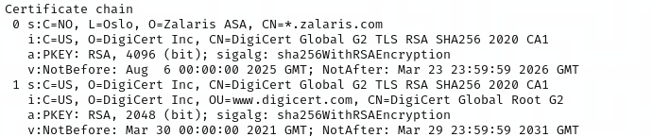

4.Cipher Suite Strength

The following ciphers are present and are confirmed as secure

- TLS_ECDHE_RSA_WITH_AES_256_GCM_SHA384 (0xc030) ECDH x25519 FS -confirmed as secure
- TLS_ECDHE_RSA_WITH_CHACHA20_POLY1305_SHA256 (0xcca8) ECDH x25519 FS -confirmed as secure
- TLS_ECDHE_RSA_WITH_AES_128_GCM_SHA256 (0xc02f) ECDH x25519 FS -confirmed as secure

WORKLOG

When | What | Who | Recommended Action
4 November 2025 | 25Q3 PeopleHub Auto 23 October - TLS Certificate re-test | CSOC | Informational. No action needed

